LifterLMS core 7.6.2

New Features

- Added functionality to disable quiz retake after a passed attempt.

Result: Passed.

Updates and Enhancements
- Adds ability to search by an order ID number in the Orders table. Thanks @bsetiawan88! #1583

Result: Passed.

- Added support for showing Private, Drafts and Pending Courses/Memberships in Reporting > Sales Page. #2490

Result: Passed.

Bug Fixes
- Fixes issue of not being able to save an imported or cloned course using Divi or the Classic Editor plugin. #2649

Result: Passed.

- Fixes broken View link after creating a new lesson using the Course Builder. #2662

Result: Passed

- Upgrading Quill text editor version. #2655

Result: Pending

Screenshot link: https://share.zight.com/12ulo7p0

But I’m able to create course, assignment, quizzes.

Developer Notes
- Added logic to delete vouchers data from table when vouchers are deleted. Thanks @bsetiawan88! #1087

Result: Pending

When you delete the data from the wp_lifterlms_vouchers_codes database table, it will remove all the voucher codes from the WordPress backend. However, deleting data from the wp_lifterlms_product_to_voucher database table does not remove the product voucher WP backend. Is that how it works? For voucher codes only and not the product voucher?

Screen recording: https://share.zight.com/E0ueY5v2

Updated Templates
- templates/admin/reporting/nav-filters.php

Test Environment 1
- Local Installation.
- Plugins Installed: LifterLMS 7.6.2
- Active Theme: Twenty Twenty Four.
- Debug mode and debug logging turned on.

Result: Passed.

Test Environment 2
- LifterLMS Test Site.
- Active Theme: Sky Pilot Theme
- Plugins Installed: LifterLMS core and other add-ons check the screenshot for the list. ( Resize the image to see all the plugins)

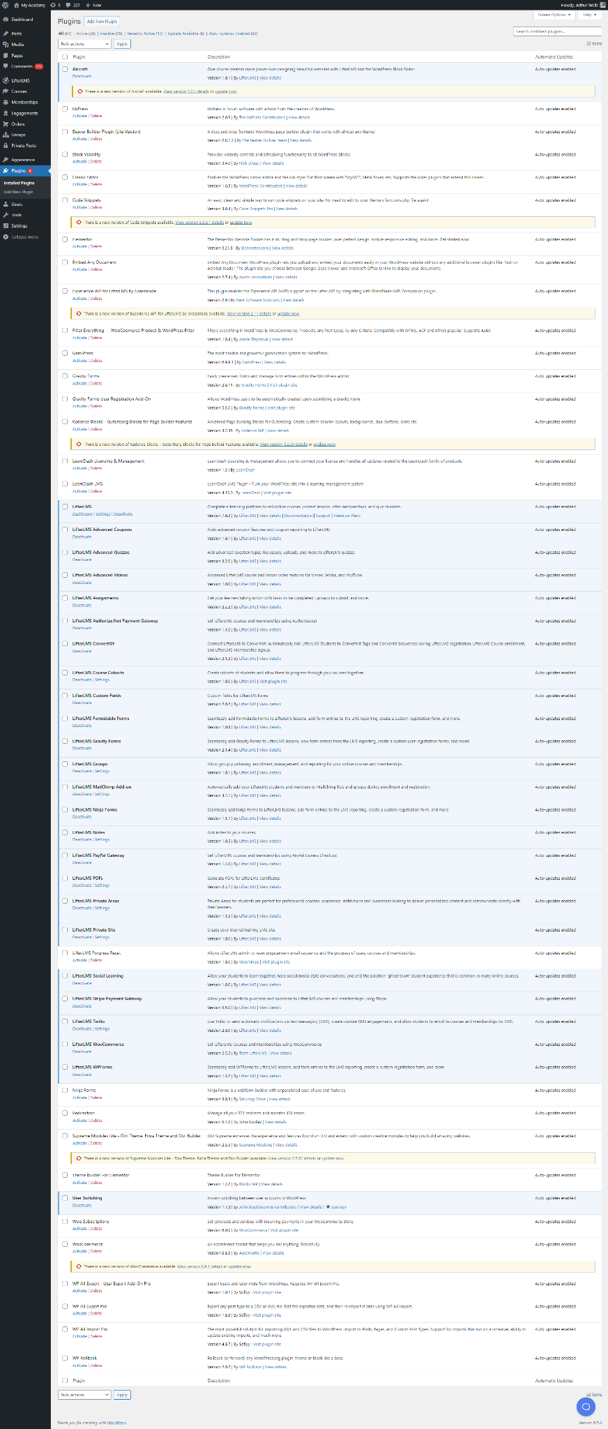

Result: Passed.

- Does the functionality work?
  - Passed.
- Does the User Interface (UI) displayed correctly ?
  - Passed.
- Does it compatible in different browser ?
  - Passed.
- Does it responsive design ?
  - Passed.
- Doesn't affect other functionalities, designs, or cause any conflicts on the site?
  - Passed.
- Does the functionality work for different users, such as Administractor, Editors, Instructors, and Students?
  - Passed.
- Are any errors displayed during testing?
  - Passed.

Core Regression Tests
- Does activating this add-on affect the layout of existing certificate templates and awarded certificates (when viewed as WordPress admin and as student and as visitor)?
  - No.
- Do all engagement triggers that trigger a certificate still work?
  - Yes
- Did the add-on introduce any issues (visual or otherwise) on the course pages when viewed on the back-end and front-end?
  - No breaking changes observed.
- Did the add-on introduce any issues (visual or otherwise) on the membership pages when viewed on the back-end and front-end?
  - No breaking changes observed.
- Did the add-on introduce any issues (visual or otherwise) on the student dashboard page?
  - No breaking changes observed.
- Did the add-on introduce any issues (visual or otherwise) on the checkout page?
  - No breaking changes observed. Checkout works and I am automatically logged in after checkout when registering as a new user.
- Did the add-on introduce any issues (visual or otherwise) on the reporting page (when viewed as an instructor and as an admin)?
  - No breaking changes observed.
- Did the add-on introduce any issues (visual or otherwise) on the course builder (when viewed as an instructor and as an admin)?
  - No breaking changes observed.
- Visually inspect and click through standard LifterLMS components. (courses, memberships, student dashboard, checkout, reporting, course builder, quiz system)
  - No breaking changes observed.
- Test an enrollment in a paid course
  - No breaking changes observed.

